Power Of Two
Platform: Leetcode
Language: C
Module 5, Question 1

Problem Link
https://leetcode.com/problems/power-of-two/description/

Problem Statement
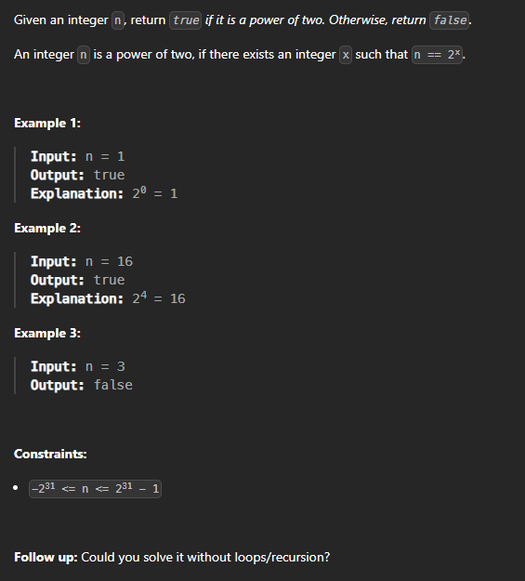

C Code
bool isPowerOfTwo(int n) {
if (n <= 0) return false;
return (n & (n - 1)) == 0; // a power of two has exactly one 1-bit
}

Screenshot of Successful Submission



